**Development of Virtual lab :Round 2 (R2)-Storyboard - Template (Worksheet)**

|  |
| --- |
| **Name of Faculty:** Ajay Kumar Dhanopia  **Institute:** Swami Keshvanand Institute of Technology and Gramothan, Jaipur  **Email ID** (as submitted in the registration form)**:** ajaydhanopia123@gmail.com  **Discipline to which the Lab belongs:** Mechanical  **Name of the Lab:** Material Science & Testing (MST)  **Name of experiment :** To study the spring testing machine and Determine the design parameters for tension and compression helical spring.  **Kindly Refer these documents before filling the worksheet**   1. **Coursework (MOOC ) on Pedagogy , Storyboard , Lab Manual :** [**http://bit.ly/Vlabs-MOOC**](http://bit.ly/Vlabs-MOOC) 2. **Additional Documentation booklet for reference.** [**http://vlabs.iitb.ac.in/vlabs-dev/document.php**](http://vlabs.iitb.ac.in/vlabs-dev/document.php) 3. **Sample Git Repository. :** |

**Round 2**

**1. Story Outline:**

The experiment consists of 8 tabs which include theory, procedure, self-evaluation, simulator, quiz, video and reference. First the user studies the concepts through theory tab and learns the procedure through the procedure tab.

User attempts pre questions which test the pre requisite knowledge of the students for the experiment.

After that, the user performs the experiment through simulations and analyze the working and calculations of the experiment. User can also analyze the output by the graphical method.

After completing simulation part, there are post-experiment quiz and assessment which tests the understanding of the concepts taught through the virtual experiment.

**2. Story**

**2.1 Set the Visual Stage Description:**

Step 1. Simulation starts with choosing the test which is tensile and compression test.

Step 2. Measure the outer and inner diameter (Do & Di respectively) of the spring with the help of Vernier scale.

Step 3. Rotate the valve of the spring test machine to close pressure valve.

Step 4. Fix the spring in the spring test machine.

Step 5. Apply the load on the spring to observe deflection. The dial gives shows the applied load.

Step 6. The next window shows the calculations and result.

Step 7: The final window of the simulator analyze the data through graphical representation.

**2.2 Set User Objectives & Goals:**

**Objective:-**Virtually we need to study the behavior of spring material as per varying load by calculating output parameter.

**Goals:-**

1. To know the working of the spring testing machine.
2. To know the moving parts of the machine.

* 1. **Set the Pathway Activities:**

First path:- we can use a simple spring balance to demonstrate the deflection of the spring when a load is applied on it. It would be very easy, it have many advantages as well as disadvantages. Some of the advantages and disadvantages are mentioned below:

**Advantages:-**

1. Setup is very simple i.e. can be modelled easily.
2. We can see this in our day to day life.
3. Conventional method

**Disadvantages:-**

1) We have to make separate weights for the apparatus.

2) Chances of error are maximum.

3) Conventional method of testing and hence is not used in the industries.

Second path:- We can use the Universal spring testing machine to calculate the spring parameters. This will help the students to learn about the machinery which is used in the industries. It also have advantages as well as disadvantages which are as follows:-

**Advantages:**

1. Student can test the springs with any type of material.
2. Student will be able to understand the hydraulic systems because it works on the hydraulic principle.
3. Student will be able to learn the working of the machine as the machine is costly and some of the institutions may lack of such type of machines.
4. High efficiency.
5. Easy to use.

**Disadvantages:-**

1. Machine may not be available at all the institutions to perform the experiment in the real world.
2. It could have errors in the dial

Here, we are using the second pathway, because it is more attractive and also give students the knowledge of the machinery. This would be sufficient for to students to know the working of machine and relate the theoretical concepts with their experimental validation.

**2.4 Set Challenges and Questions/Complexity/Variations in Questions:**

Pre- assignment: Pre experiment quiz test is focus on the basic knowledge of the user about the topic. It gives a brief idea to user about the experiment and the working principles.

Post assignment: Post experiment assignment is designed in such a way that is test the understanding of user to learn the concepts shown. The quizzes is consists of question of the levels easy, medium and logical and critical thinking based, where the developer easily examine user level.

* 1. **Allow pitfalls:**

1. The student could be confused between the compressive and the tensile springs.
2. The student could be confused between the relation between the load applied and the deflection. After the experiment he will understand that there is a linear relationship between the applied load and deflection.

**2.6 Conclusion:**

By doing this experiment we had studied the behavior of helical steel spring in different load conditions. We had also calculated maximum shear stress and maximum torque in of the spring by doing this experiment virtually.

**2.7 Equations/formulas:**

1) Stiffness of spring (k): --

k=w/δ

Where k = spring stiffness (kg/mm)

w = applied load

δ = deflection

2) Spring index(c): --

c=D/d

Where D= mean distance of coil spring

d = spring wire distance

c = spring index

3) Max shear stress (Fs): --

Fs = 16.t/πd3 kg/mm2

4) Torque (t):--

t=w.r kg-mm

r=D/2 mm

5) Deflection (δ) :--

δ=64wr3n/Gdd3

δ=64w.(D/2)3n/Gdd3

δ=64wD3n/8Gdd3

δ=8wD3n/Gdd3

δ=8.wc3n/Gd4

δ=8wD3n/Gd4  mm

**3. Flowchart:**

**4. Mindmap:** <https://mm.tt/1349275753?t=rtfwgYsrW3>

Test is

Tensile or

Compressive

Measure the inner and outer diameter

Set the spring in the machine in upper part

Rotate the valve

Take input in forum of load

Show the calculation

Measure the inner and outer diameter

Set the spring in the machine in lower part

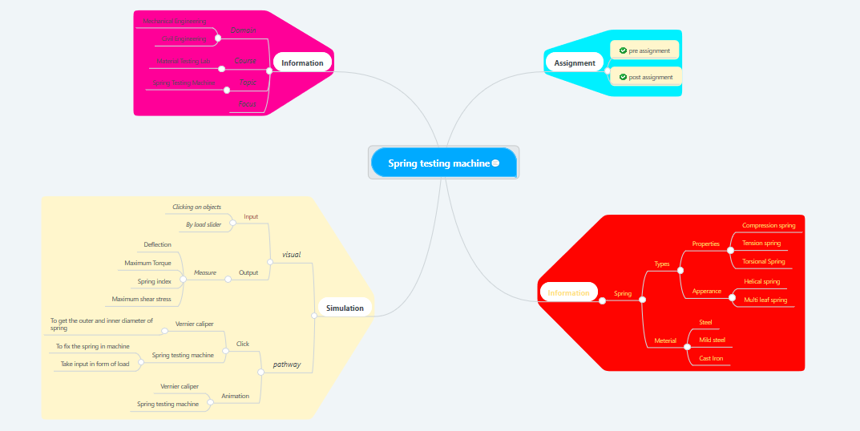

**5. Storyboard:**





